Changes For Website
For every point that needs to be changed, please include the following info. Here’s a sample of how to explain the change needed

Sample

Page URL: http://www.pharmachitchat.com/about/
Screenshot of section that needs to be changed:


Change Needed: Please change the categories box background from blue to green. Sample green color that we like:
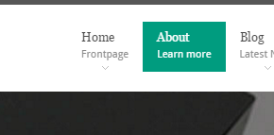

- Page URL:
Screenshot of section that needs to be changed:

Change Needed:

- Page URL:
Screenshot of section that needs to be changed:

Change Needed:

- Page URL:
Screenshot of section that needs to be changed:

Change Needed:

- Page URL:
Screenshot of section that needs to be changed:

Change Needed:

